MBA 803 – Fundamentals of Finance
Interest Rates

- Factors Affecting the Nominal Interest Rate
    - Real vs. Nominal Interest Rates
        - The nominal interest rate is the rate quoted by financial institutions and the one typically used in TVM calculations.
The real interest rate is the rate of growth of your purchasing power, after adjusting for inflation.

$$1+r_{r}=\frac{1+r}{1+i}=\frac{\text{Growth of Money}}{\text{Growth of Prices}}$$
$$⇒r_{r}=\frac{r-i}{1+i}≈r-i$$

        - Example: In 2008, the average 1-year Treasury Constant Maturity rate was 1.82 percent and the inflation rate was 0.28 percent. What was the real interest rate in 2008?

        - Note: What really matters is the expected rate of inflation, not actual inflation.
    - Factors Affecting Nominal Interest Rates
        - More broadly, any nominal (stated) interest rate can be broken down into its component parts (at least theoretically):

$$r=r^{*}+IP+DRP+LP+MRP \\ =r_{rf}+DRP+LP+MRP$$

        - In this expression:

            - $r^{*}$ = real, risk-free interest rate.

            - $r_{rf}=r^{*}+ IP$ = nominal, risk-free interest rate.

                - Treasury bills (T-bills) are the closest things we have to truly risk-free securities, since they are short-term, have virtually no default risk, and are very liquid. Thus, the T-bill rate is a good proxy for the nominal risk-free rate.

            - $IP$ = Inflation premium

            - $DRP$ = Default risk premium

            - $LP$ = Liquidity premium

            - $MRP$ = Maturity risk premium

        - Several points are worth noting:

            - Short-term treasury securities include only an inflation premium.

            - Long-term treasury securities contain an inflation premium plus a maturity risk premium.

            - The rate on short-term corporate securities is equal to the real risk-free rate plus premiums for inflation, default risk, and liquidity.

            - The rate for long-term corporate securities also includes a premium for maturity risk.

- Term Structure of Interest Rates and the Yield Curve
    - The term structure of interest rates is the relationship between interest rates, or yields, and maturities of securities. This relationship is portrayed graphically in the yield curve.

        - Figure 5.2 – Term Structure of Risk-free U.S. Interest Rates, November 2006, 2007 and 2008
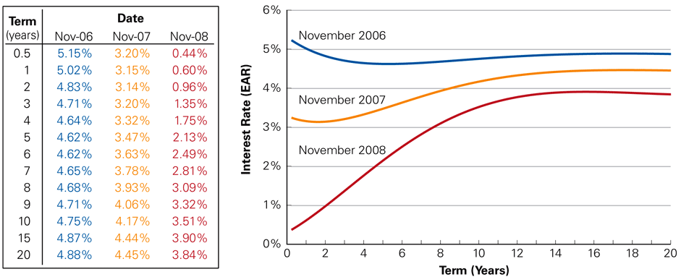

    - The shape of the yield curve is influenced by interest rate expectations.

        - The normal shape is upward sloping, meaning that investors demand a higher return for long-term investments.

        - Sometimes, however, the yield curve inverts

        - Figure 5.3 – Short-term vs. Long-term U. S. Interest Rates and Recessions

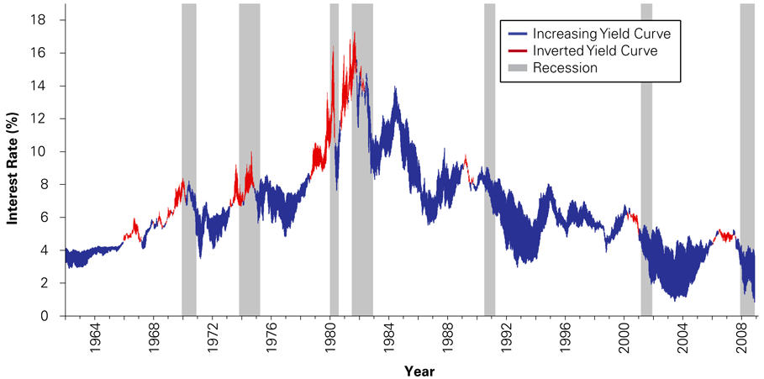

    - Based on the data used in Figure 5.3, in November 2008 what did markets expect the 1-year interest rate would be in November 2009? November 2010?

        - Note: This analysis is based on the pure expectations theory of the yield curve.

    - The text talks about how the term structure can be used to discount cash flows that occur at different points in time.

        - While this is technically correct, it is common practice to assume a constant (average) discount rate over time.

- Risk and Taxes
    - Risky cash flows should be discounted using an interest rate related to the risk associated with the cash flows.

    - Taxes affect the final cash flows an investor receives from a project. As a result, it is often appropriate to use an after-tax interest rate when comparing different investment alternatives.

- The Opportunity Cost of Capital
    - The opportunity cost of capital (or cost of capital) is the best available expected return offered in the market on an investment of comparable risk and term to the cash flow being discounted.

